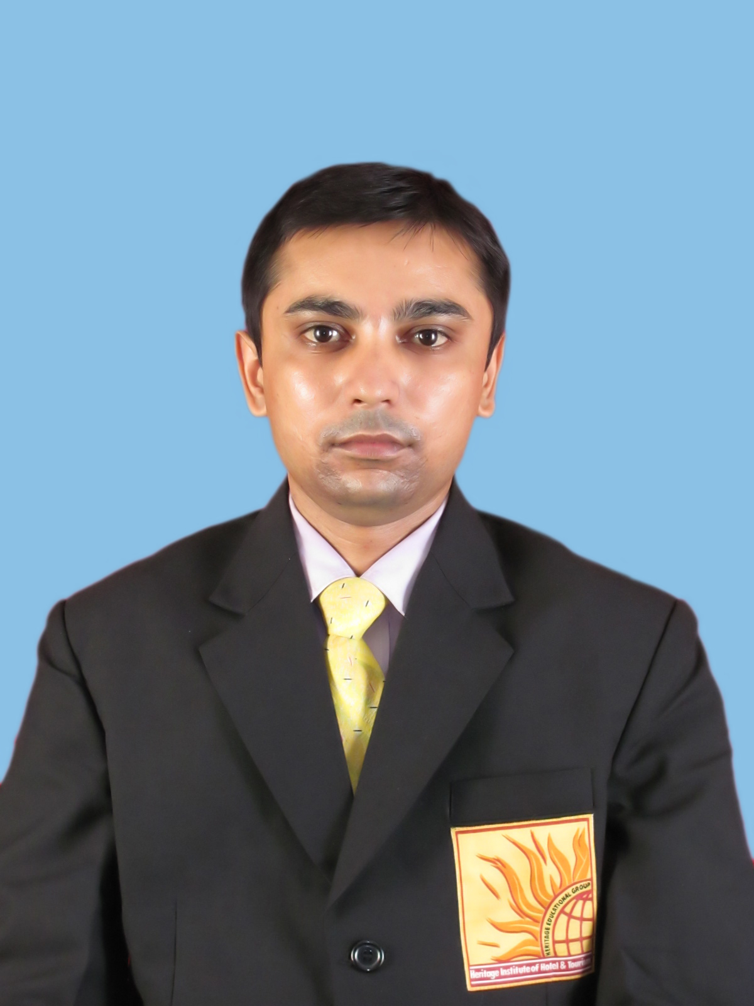
ROHIT ANAND
PRESENT ADDRESS

Date of Birth :- feb-28-1986
Nationality :- Indian

PRESENT ADDRESS :

Kamakashi Hotel F . L Gomes Road
Opp RTO Office
Vasco Da Gama
State- GOA.
Contact Number :- +91-8340232548,9096092206,9665670302
Email address :- rohit.hiht02@gmail.com

PERMANENT ADDRESS

FATHERS NAME : Binay Kumar Sinha
IEL Colony Gomia
Flat No # E 30/1
P.O # I.E Gomia
Disst # Bokaro Steel City
STATE # Jharkhand
PIN # 829112
PHONE NO # +91-9931350441,8092181402

Vision and Objective :
To work in an environment where my knowledge and management skills are effectively utilized and assure productive services which will satisfy the organization.

Academic Projects:-
6 Months Industrial Training from Vivanta By Taj Panjim, GOA in 15th october 2010 to 15th march 2011.

Academic Credentials:-

YEAR- 2009 To 2012
Completed three year degree course of Integrated B.SC in Hotel Management Catering Technology & Tourism from Heritage Institute Of Hotel & Tourism, Goa , Certified Institution Punjab Technical University,Jalandhar.

I Have Also Completed Certified Course Of Retail Management & Aviation From Heritage Institute Of Hotel & Tourism Vasco Da Gama,GOA.

10+2 :- YEAR 2005
From Doranda College Ranchi, Jharkhand

10th :- YEAR 2002
R.K High School Jasidih, Jharkhand

EXPERINCE : 3 Years Experince In Front Office Department In
Kamakshi Hotel Pvt.Ltd. Vasco Da Gama,GOA.
: I Have completed 1 Year Experience As a Front Office
Associate In Front Office Department In Hotel Aakar
Lords Inn Saputara Distt # Dang, Gujarat.

HOBBIES
- I like To Dedicate My Job In Hospitality & Tourism Industry & Interacting With The Public Dealing & Friendly Relationship With The Customers.

LANGUAGE KNOWN:- English and Hindi

DATE :
PLACE: ROHIT ANAND Signature:

